**UI Design and Prototyping**

**Courses system for students:**

Let`s define teacher as admin who can add exams and questions for the student to solve it and even to have some companions with other student. This platform that allows student from all grads to communicate each other and even play together and solve exams at any subjects they have or they study in the school to make it more fun and attractive for them to lean more.

The website will allow users to register, post there scores and even if they have better solution for the question they have and shear there scores on there profile.

Finally, both teacher and student could set list of comment about the new question the teacher create and student to review the exams and give their impression on the exam level.

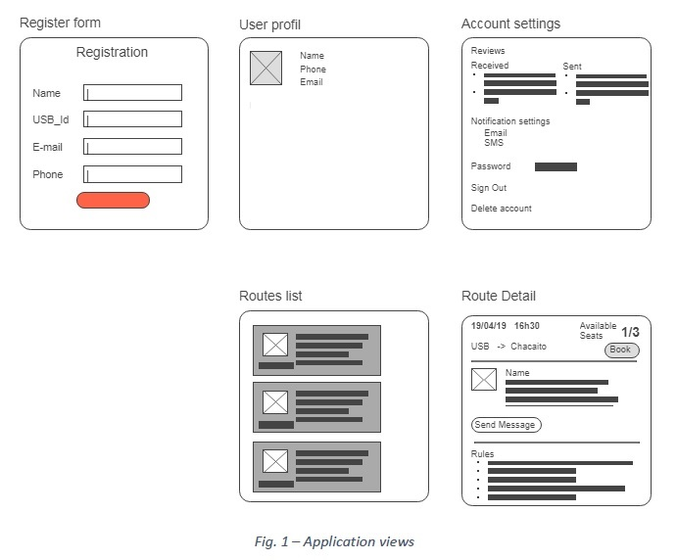

Student start with registered/login page, after that they setup their profile and even have code to add their friends in the class to start to solve questions together.

Teacher will have access to there exams and even to add new exams or questions. And comminate with their student and even put timer for them to solve it.

References:

<https://www.duolingo.com/>

<https://www.englishclub.com/>

https://esl.culips.com/